Installation for 6 X 6 Base

**6 x 6 frames should be no greater than dimension of unit**
Double Unit 6x6 Base: (There will be approximately a 1” overhang of shower on 6x6 Base)
10 qty. - 5” x 3/8” Galvanized lag bolts
Double 46” Units: Double 36” Units:
2 qty. – 44” Pressure Treated Wood 2 qty. – 34” Pressure Treated Wood
2 qty. – 86” Pressure Treated Wood 2 qty. – 66” Pressure Treated Wood
10 60lb. bags of 3/8 gravel 8 60lb. bags of 3/8 gravel

Single Unit 6x6 Base: (There will be approximately 1” overhang of shower on 6x6 Base)
8 qty. - 5” x 3/8” Galvanized lag bolts
Single 46” Units: Single 36” Units:
4 qty. – 44” Pressure Treated Wood 4 qty. – 34” Pressure Treated Wood
5 60lb. bags of 3/8 gravel 4 60lb. bags of 3/8 gravel

- Create a lap joint at 5 ½” in length and 2 ¾” in depth on both ends of each piece of wood.
- Overlap each cut out connection and fasten with (2) 5” x 3/8” lag bolts.
- Flip the frame over to ensure a smooth surface for the aluminum frame installation.
- Dig the wood sub-frame into the ground and make sure it is level and stable around the perimeter. Fill the interior with 3/8” stone for a French drain. * 6x6 base should be FLUSH/LEVEL to pavers or grade.
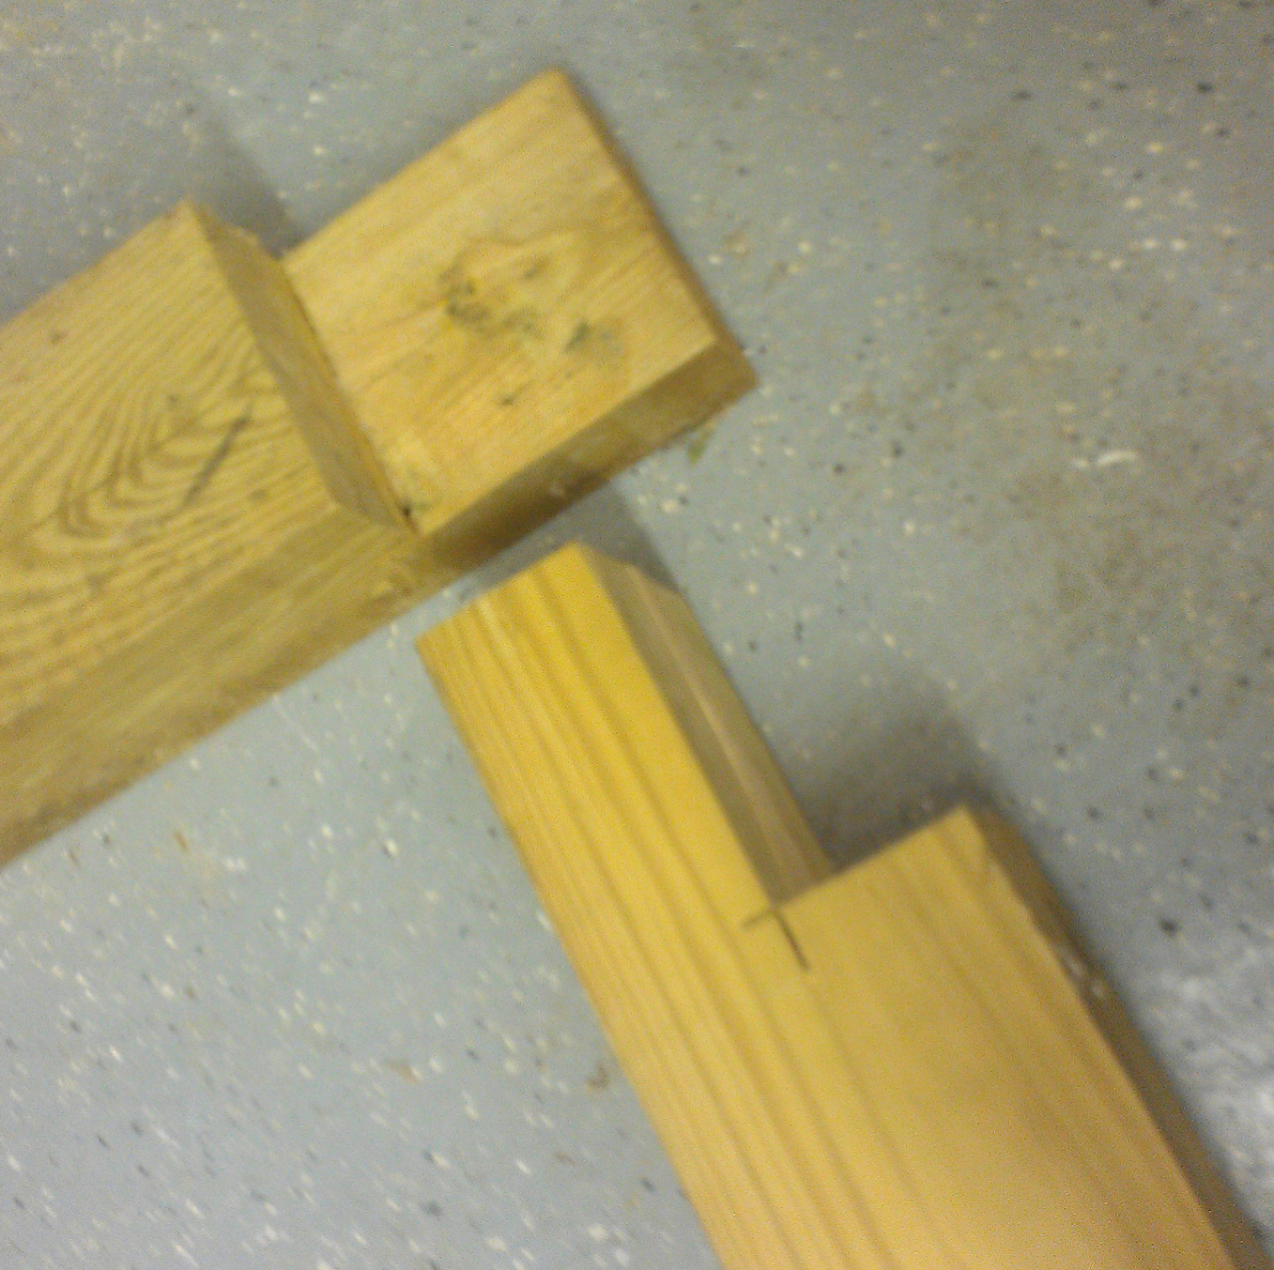
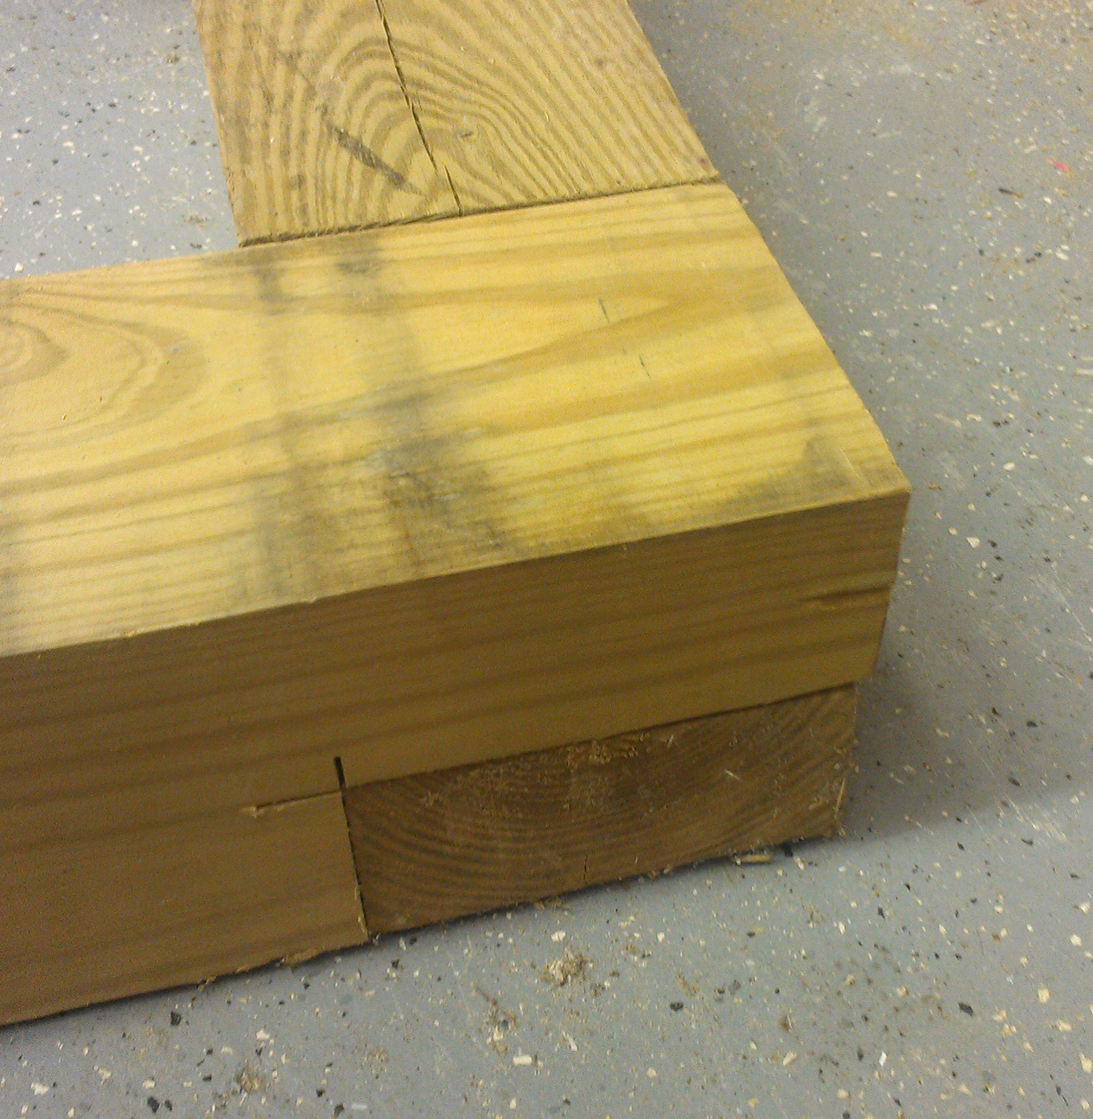
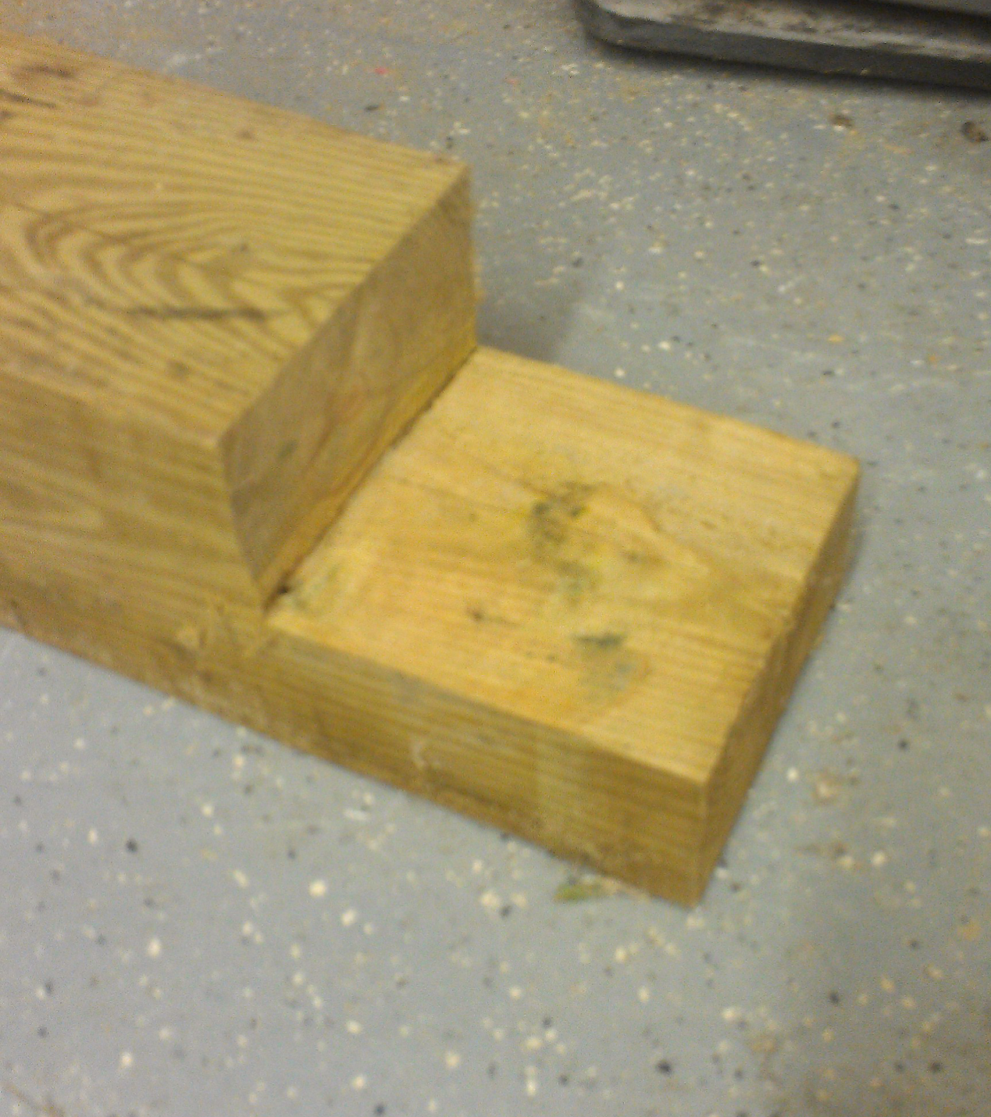
- PLEASE NOTE* - Unit will overhang 1” on all four sides when installing it to the wood for future pavers or tuck stone or dirt.

